A

PROJECT REPORT

ON

Food Ordering System (Indian Taste)

Submitted to partial fulfillment for the Degree of

Bachelor of Computer Application

(**B.C.A SEM-:6**)



**Group No: - 03**

**Submitted by**

**Joshi Akash.B (Exam No:- 97)**

**Mehta Takshal.H (Exam No:- 173)**

**Mehta Neel.K(Exam No:- 154)**

**Guided By**

**Prof. Mukesh Chauhan**

**Submitted To**

**THE I.N.S.B. INSTITUTE OF INFORMATION**

**TECHNOLOGY AND MANAGEMENT STUDIES BCA COLLEGE, IDAR March/April of 2024-25.**

THE **I.N.S.B. INSTITUTE OF INFORMATION TECHNOLOGY AND MANAGEMENT STUDIES** BCA COLLEGE, IDAR

**C E R T I F I C A T E**

This is to certify that Mr/Mrs **Joshi AakshKumarBharatBhai**.(Enrollment No: BCA11022080373), **Mehta TakshalKumarDhirenBhai**.(Enrollment No: BCA11022080382), **Mehta NeelkumarKetanBhai**.(Enrollment No: BCA11022080383) hasbeen satisfactorily presented **Final Year Project** entitled as **“Food Ordering System (IndianTaste)”** as a part of their study curriculum SYSTEM DEVELOPMENT PROJECT (BCA-605) of the term ending in March/April of 2024-25.

Date:

**Signature of Internal Guide** **Principal**

**Prof. Mukesh Chauhan Dr. Sudhirkumar J. Patel**

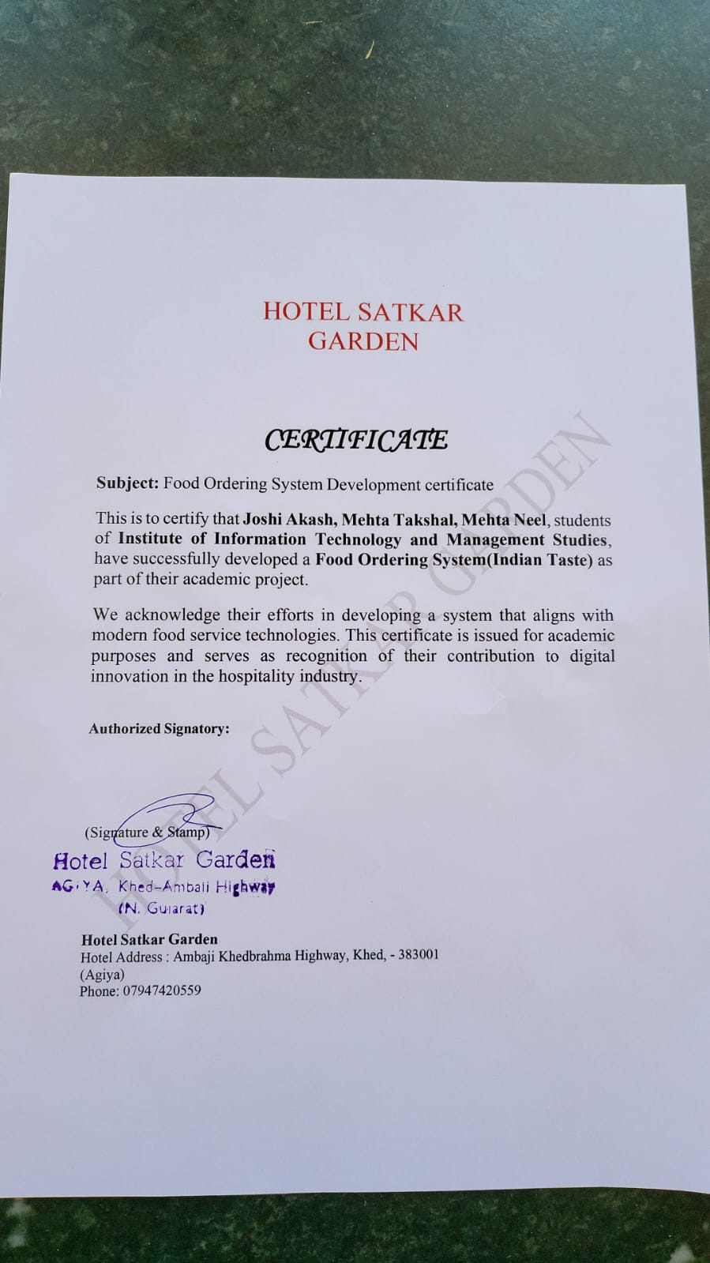

PREFACE

This project report is submitted as part of the coursework undertaken at **the( I.N.S.B). Institute of information technology and management studies bca college, idar**, Idar Arts & Commerce College Campus, Valasana Road, Jawanpur, Idar, affiliated with **Hemchandracharya North Gujarat University**.

The development of this **Food Ordering System(Indian Taste)** aligns with the practical requirements of understanding and applying concepts in software development, database management, and user interface design. This system is designed to simplify the process of ordering food, offering a platform where users can browse menus, place orders, and receive their meals conveniently and efficiently.

In the same way that financial and resource constraints impact many modern enterprises, this project reflects the importance of optimizing operations within such limitations. Whether it is a restaurant or an e-commerce business, organizations of all kinds face challenges that require innovative and technology-driven solutions to meet customer demands and streamline operations.

This report presents a comprehensive account of the design, implementation, and potential real-world applications of the Food Ordering System. The system aims to demonstrate how digital solutions can enhance user experiences and improve organizational efficiency, serving as a prototype for similar business scenarios.

ACKNOWLEDGEMENT

We can sincerely say that the **Food Ordering System (Indian Taste**) is a platform designed to provide users with a seamless and convenient way to order food online. This system allows users to explore a wide variety of menus, place orders, and enjoy meals from their favorite restaurants, all through our secure and user-friendly website.

Using the **Indian Taste** service, users can enjoy features like:

* Browsing menus with detailed descriptions and images.
* Placing orders with status and delivery.
* Secure payment options and order tracking, enhancing their overall experience.

We are grateful to **Dr.Sudhirkumar J. Patel** (Principal of Department, B.C.A) for providing us with all the facilities required for the successful development of this project.

We would like to extend our heartfelt thanks to our internal project guides, (**Asst. Prof.)** **Mukesh Chauhan**, for her invaluable guidance, constructive feedback, and support throughout this project. Her mentorship played a crucial role in steering us in the right direction.

Last but not least, we deeply appreciate all those who have supported us directly or indirectly in making this project a success. Your encouragement and assistance have been instrumental in bringing this idea to life.

INDEX

1. About University 1

2. About Institute 2

3. PROJECT PROFILE 3

4. SOFTWARE SPECIFICATION(Minimum) 4

5. FUNCTIONAL SPECIFICATION 5

6. USERS OF THE SYSTEM 5

7. DFD(Data flow diagrams) 6

8. E-R DIAGRAM 10

9. Data Dictionary 11

10. VISITOR INTERFACE DESIGN 14

11. ADMIN INTERFACE DESIGN 20

12. BIBLIOGRAPHY 28

13. WEB REFERENCES 29

## 

## 1. About University

The region of North Gujarat, encompassing the districts of Patan, Mehsana, Banaskantha, and Sabarkantha, holds a rich cultural and educational heritage. To cater to the academic and developmental needs of this area, the University of Patan was established in 1986 through the North Gujarat University Act (Act No. 22 of 1986).

The University of Patan Act No. 22 of 1986, enacted by the Legislative Assembly of Gujarat, marked a significant milestone in higher education in the region. Upon its establishment, the university began its operations independently, without inheriting physical assets from any parent institution. Despite initial challenges, it laid a strong foundation for academic excellence and cultural preservation.

Since its inception, the **University of Patan** has been committed to providing quality education across diverse fields, fostering innovation, and nurturing talent. The university has grown steadily, expanding its infrastructure, introducing cutting-edge academic programs, and building strong community engagement initiatives.

Today, the **University of Patan** stands as a prestigious institution, empowering students, advancing research, and contributing to the socio-economic development of the region. It continues its journey of excellence with a vision to shape future leaders and make a lasting impact on society.

## 2. About Institute

The **I.N.S.B Institute (Institute of Information Technology and Management Studies)** is a premier educational institution dedicated to shaping the future of students through excellence in education, innovation, and research. Located at the heart of **Valasana Road, Idar**, **I.N.S.B** has become synonymous with quality education and a commitment to developing the leaders of tomorrow.

#### ****Our Vision****

To empower individuals with knowledge and skills that inspire innovation and contribute to the betterment of society.

#### ****Programs Offered****

**I.N.S.B** offers a wide range of programs designed to cater to the needs of students and professionals in today’s competitive world, including:

* **Undergraduate Courses**: BCA
* **Postgraduate Courses**: PGDCA

#### ****Why Choose INSB?****

* **Experienced Faculty**: A team of highly qualified and dedicated educators.
* **Modern Infrastructure**: Smart classrooms, advanced labs, and a well-stocked library.
* **Industry Connections**: Strong ties with industry leaders for internships, placements, and training.
* **Holistic Development**: Focus on extracurricular activities, leadership programs, and community engagement.
* **Placement Support**: Dedicated placement cell ensuring students step into the professional world with confidence.

#### ****Core Values****

* Excellence in Education
* Integrity and Ethics
* Innovation and Research
* Inclusivity and Diversity

## 

## 3. PROJECT PROFILE

| | Project Title | Food Ordering Website | | --- | --- | | Project Objective | The main objective of this Website is to provide a seamless and user-friendly platform for customers to order food online from their favorite restaurants. | | Types Of Application | Website | | Front–End | Html, Css, Bootstrap, Javascript, Ajax | | Back–End | PHP 8.2.4 MySqli Server | | Other Tools | PhpMyadmin, VSCODE , AdobePhotoshop, Ms-office | | Internal Guide | Assi.Mukesh Chauhan | | Time Duration | 90 Days | | Submitted To | **The (I.N.S.B). Institute of information technology and management studies** | | Developed By | Akash Joshi, Neel Mehta, Takshal Mehta. | | | |  |
| --- | --- | --- | --- | --- | --- | --- | --- | --- | --- | --- | --- | --- | --- | --- | --- | --- | --- | --- | --- | --- | --- | --- | --- |
|  | | |  |
|  | 4. SOFTWARE SPECIFICATION(Minimum) **Server side**   |  |  | | --- | --- | | Operating System | Window 10 | | Web Server | Apache /2.4.56 | | Database Server | MySQL 10.24.2 | | Runtime Environment | PHP/8.2.4 |   **Client side**   |  |  | | --- | --- | | Operating system | Window 7, 8 ,10, 11 any | | Web Browser | Any Compatible Browser | |  |
|  |  |
| 5. FUNCTIONAL SPECIFICATION | | |
|  |

* **Module:-**
* Login
* Resignation
* Forgot password
* Places orders
* Add to cart
* Wallet
* Payment

## 6. USERS OF THE SYSTEM

In our system there are three users who can work on the system they are :

1. Admin
2. User

**■ User specification**

* Admin:-
  + Admin can login & then manage the site.
  + Admin can reset their password.
  + Admin can manage their profile.
  + Admin can manage Users.
  + Admin can manage dish.
  + Admin can Logout.
* **User:-**
  + - * User can register.
      * User can login.
      * User can change password.
      * User can order dish.
      * User can Logout.

## 7. DFD(Data flow diagrams)

0th Level DFD

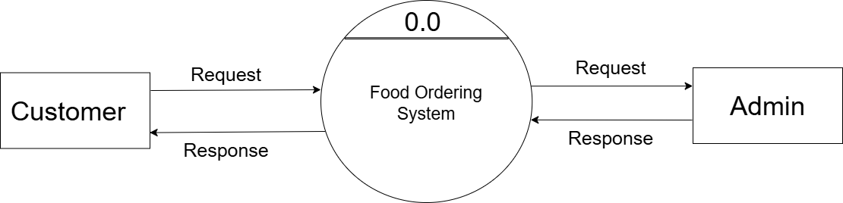

1th Level DFD

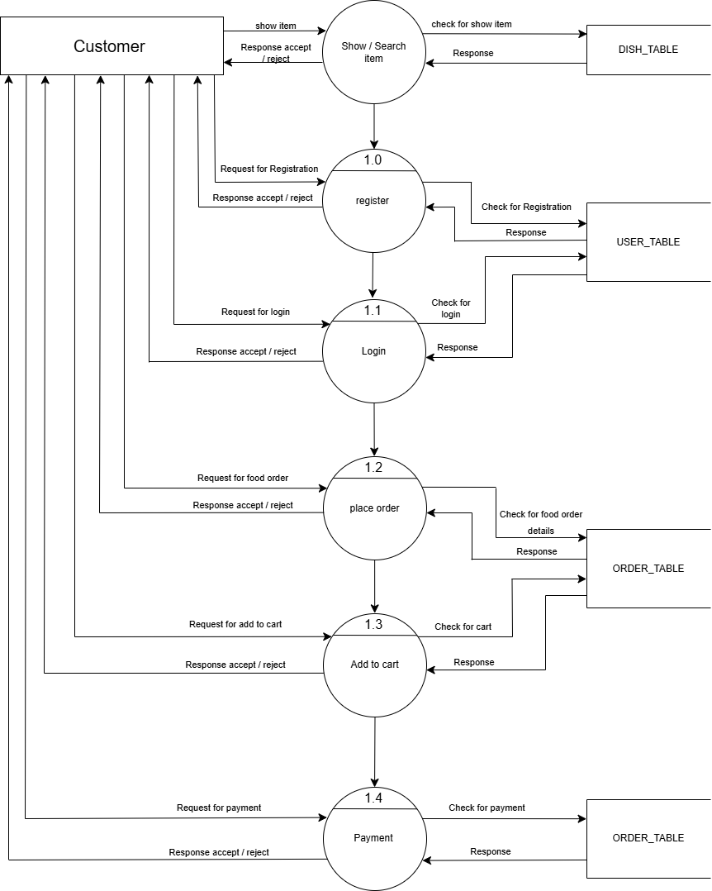

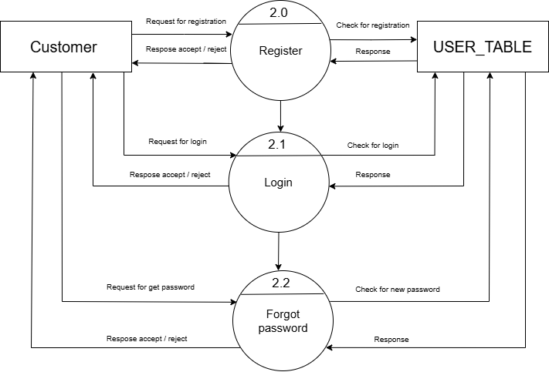2th Level DFD

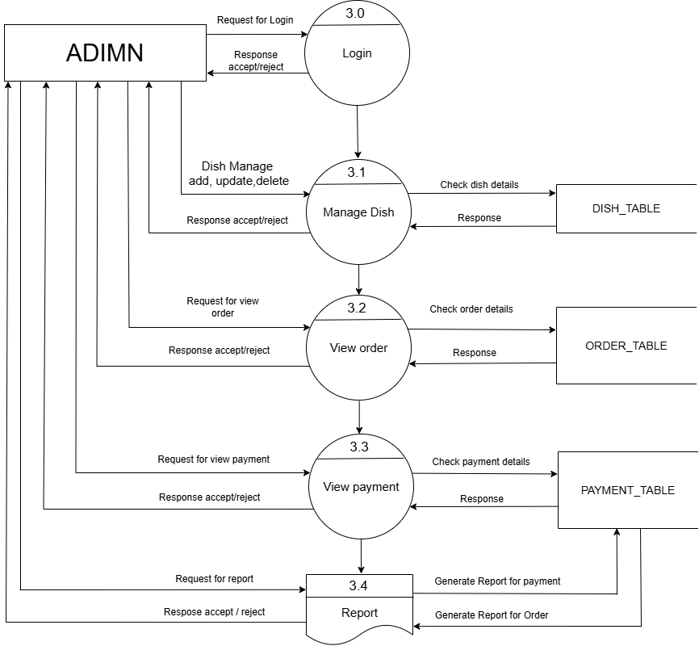Admin- side DFD

## ER-diagram.drawio.png8. E-R DIAGRAM

## admin.png9. Data Dictionary

Admin-table

Dish-table

## Dish-details.pngdish.png

Dish-Details-table

Category-table

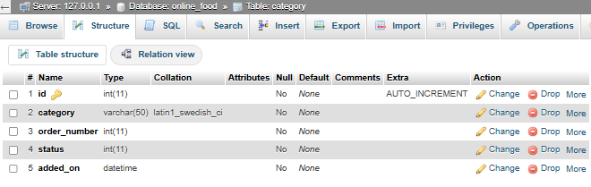

Order-master-table

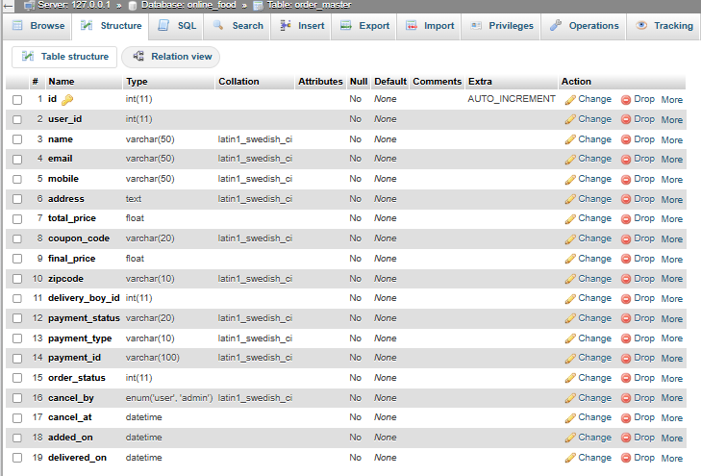

User-table

## user.png

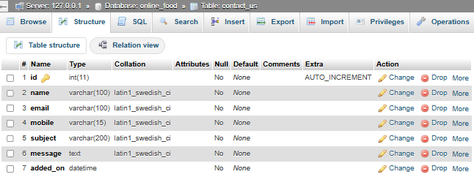Contact -us-table

## 10. VISITOR INTERFACE DESIGN

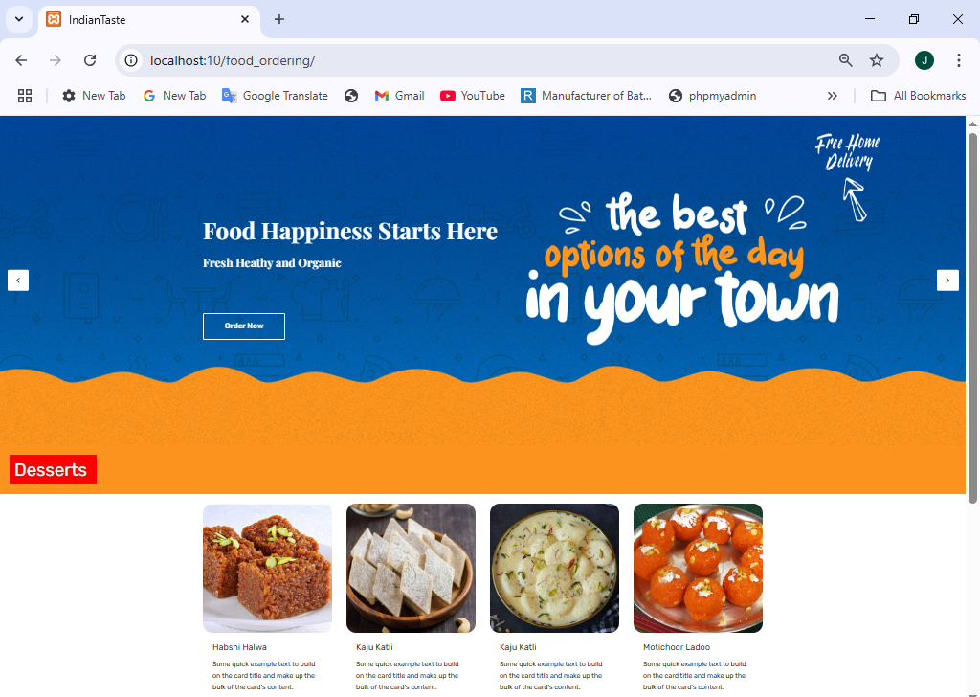Index page

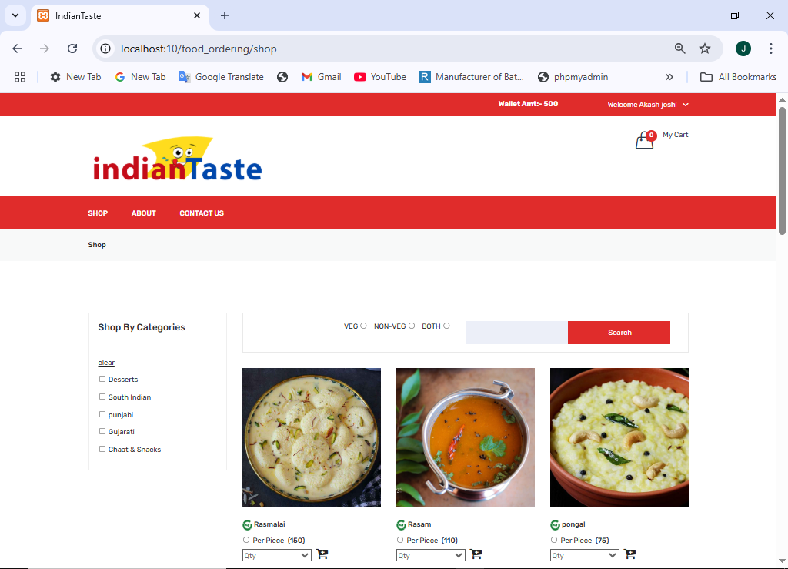Shop page

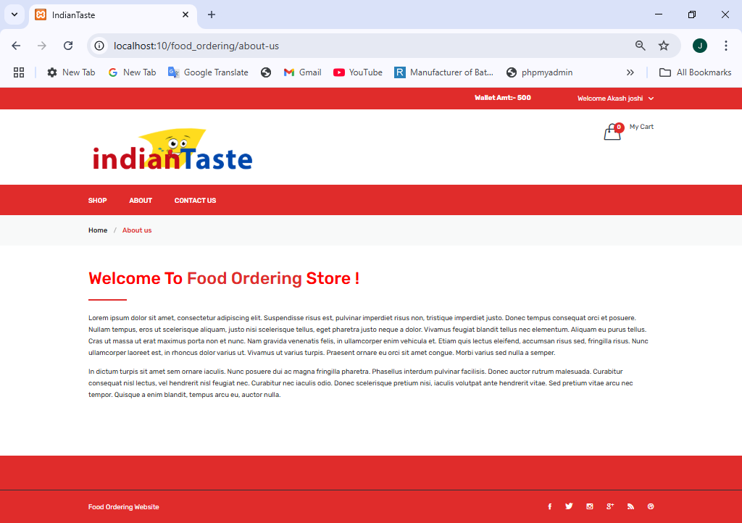About-us page

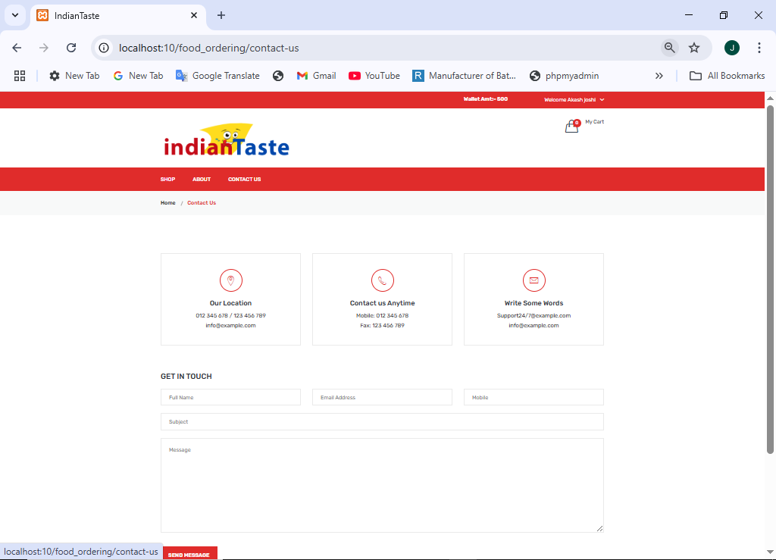Contact –us page

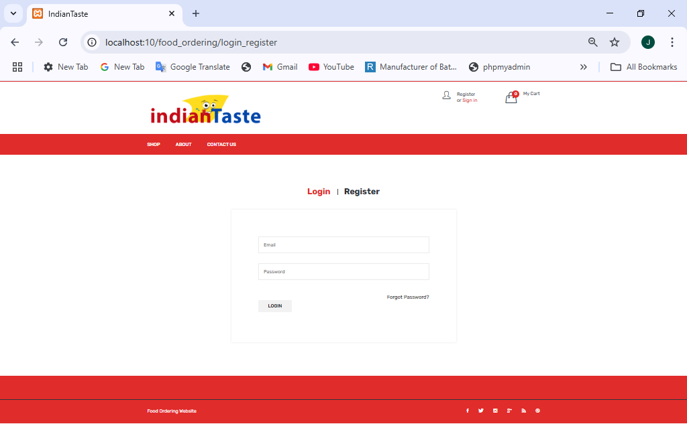Login page

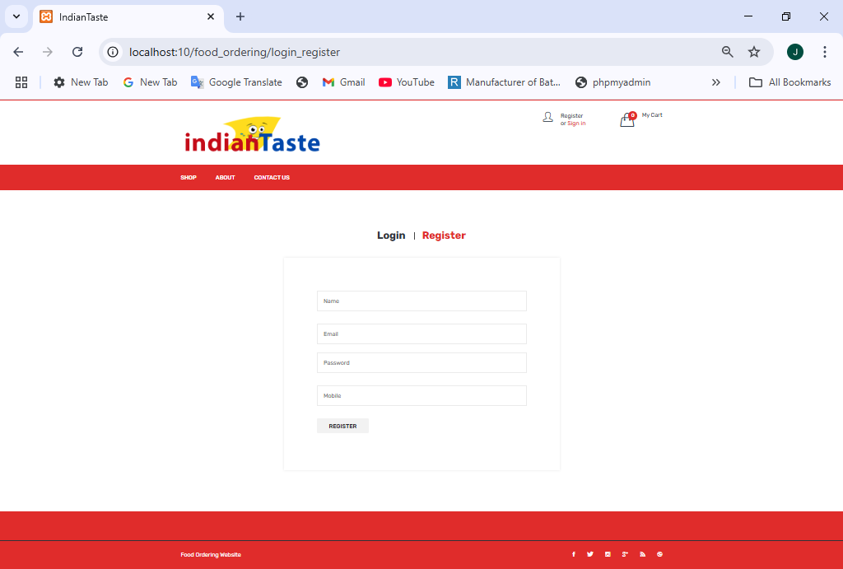Registration page

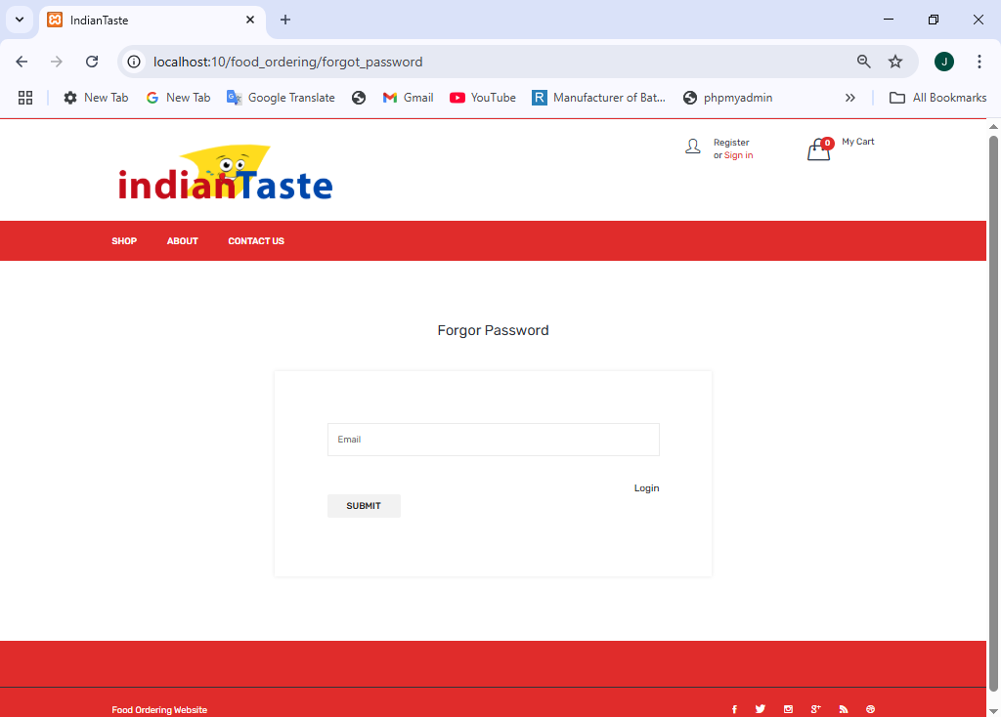Forgot password page

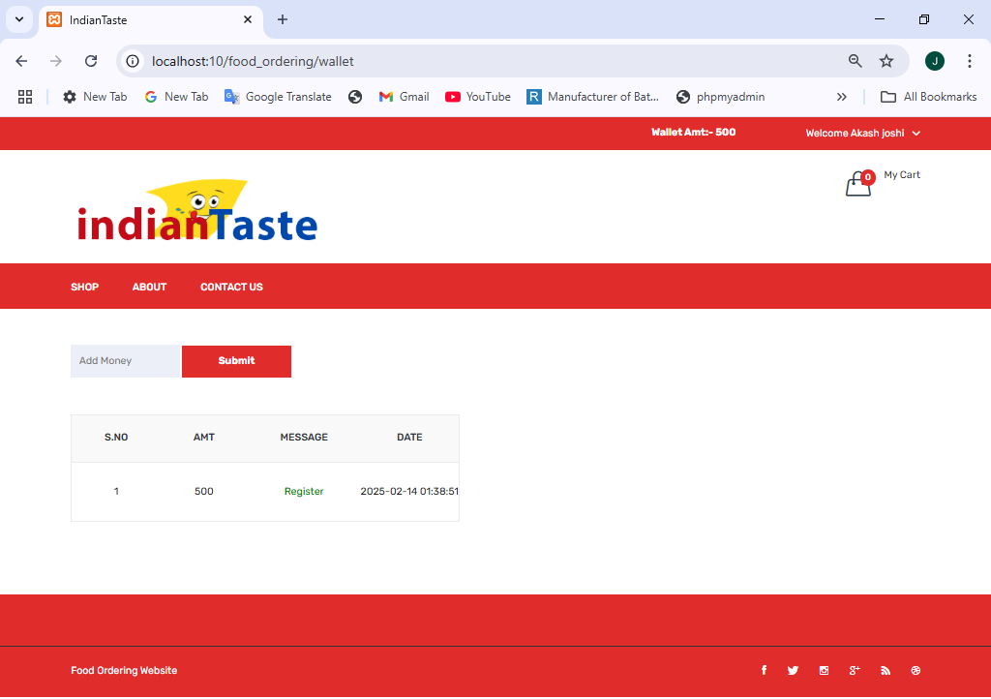

Wallet page

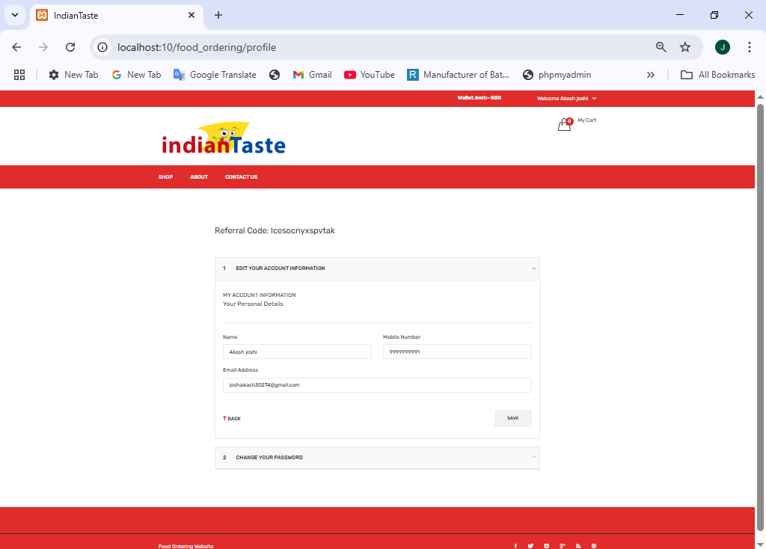Profile page

Order history

## page7.png

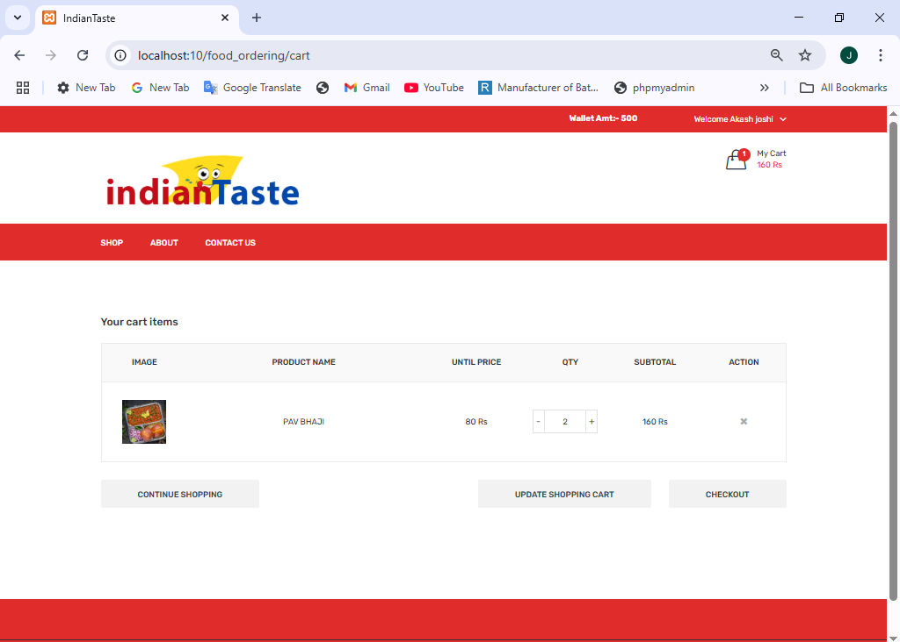Add to cat app

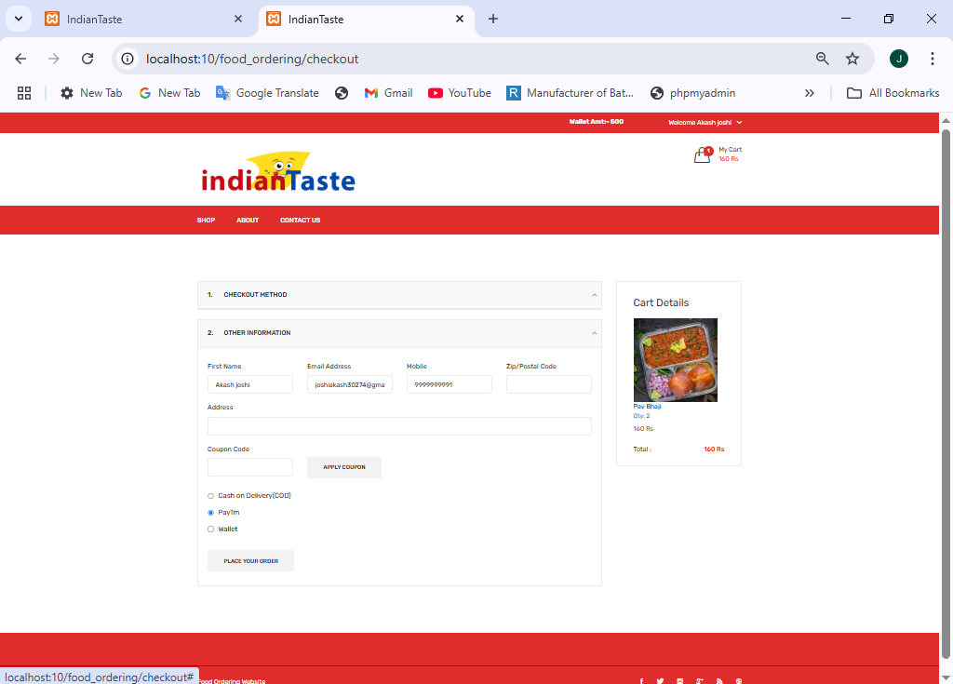Checkout page

## 11. ADMIN INTERFACE DESIGN

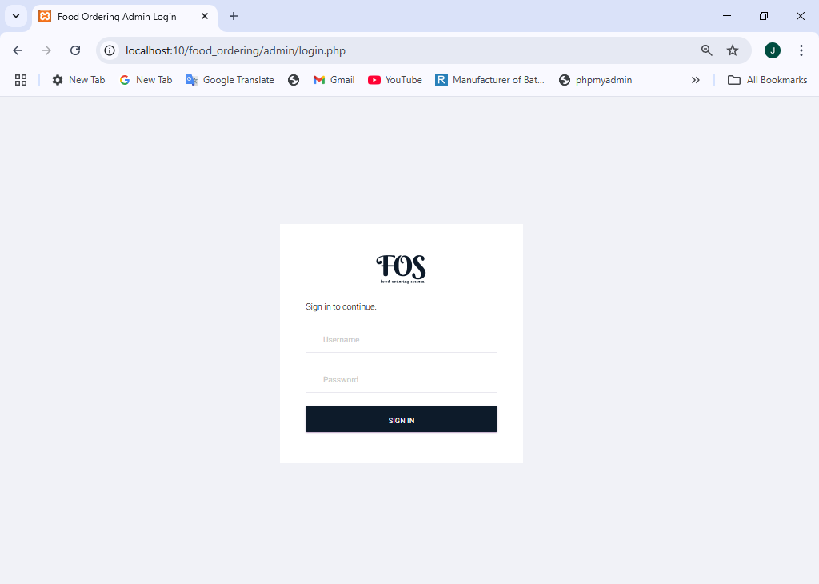Admin login

Dashboard page

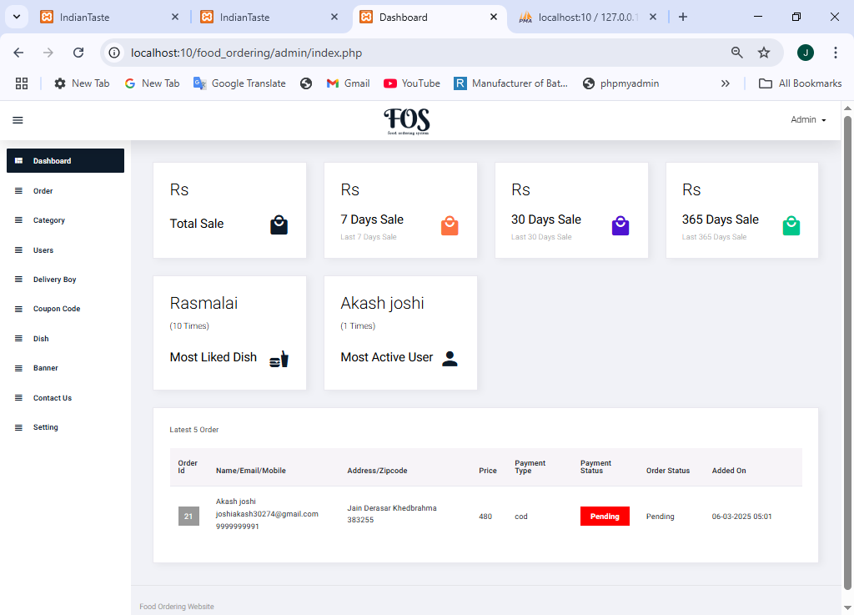

Order page

## page3.png

Category page

## page4.png

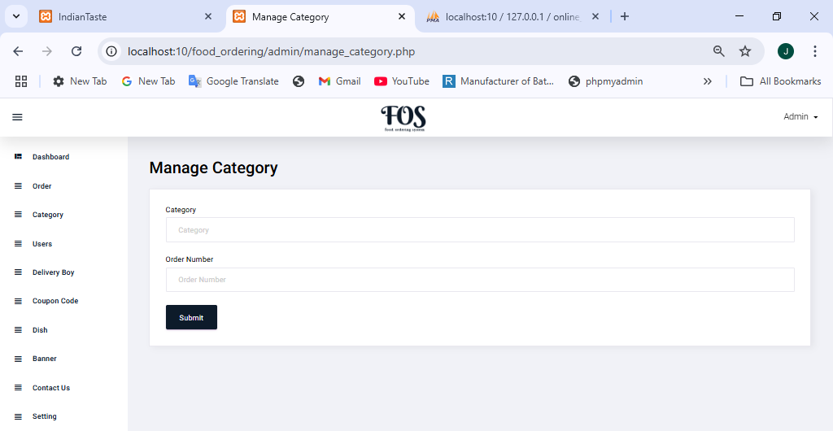manage-category page

User page

## page6.png

Delivery–boy page

## page7.png

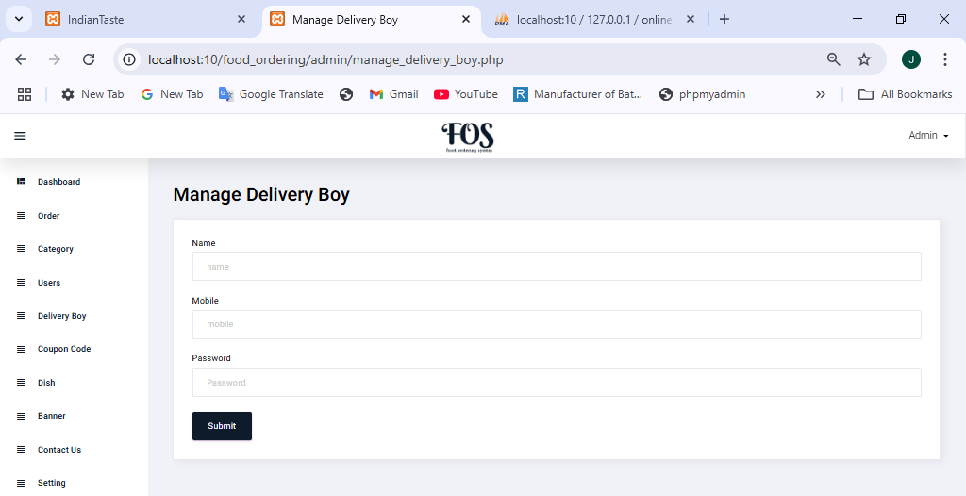Manage-Delivery–boy page

## 

Coupon code master

## page9.png

Manage-Coupon code master

## page10.png

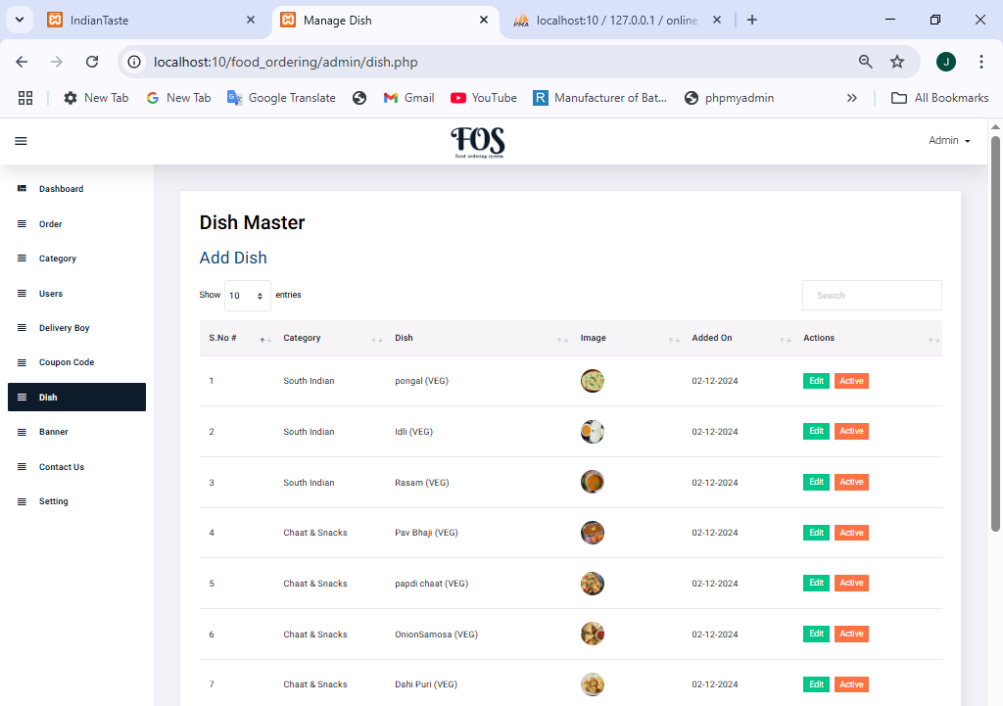Dish page

Manage-dish

## page12.png

Banner page

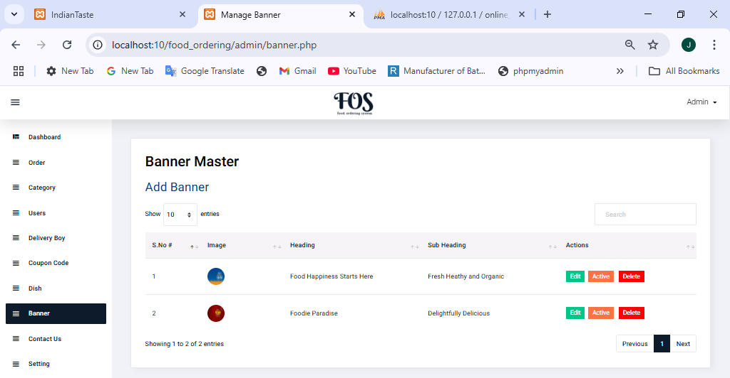

Manage -Banner page

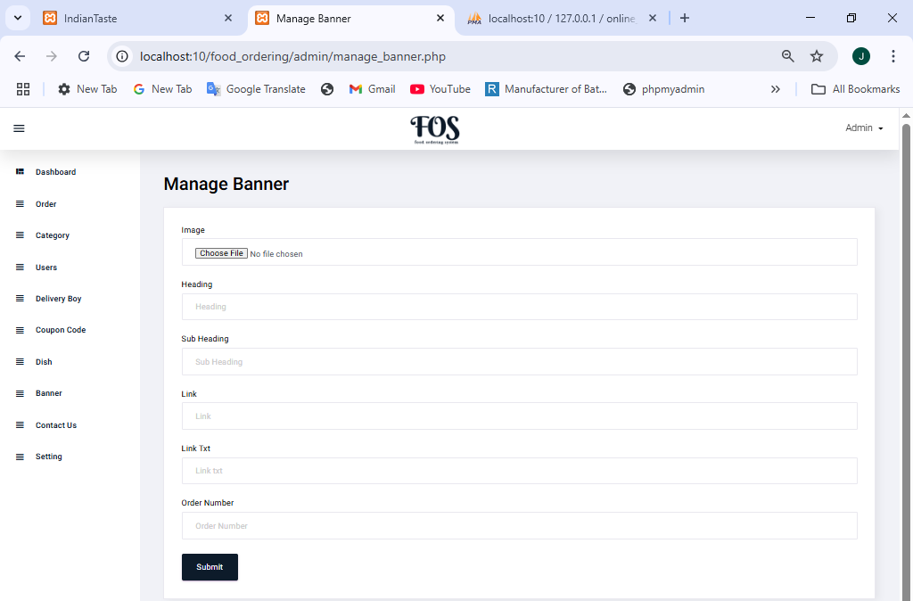

Contact page

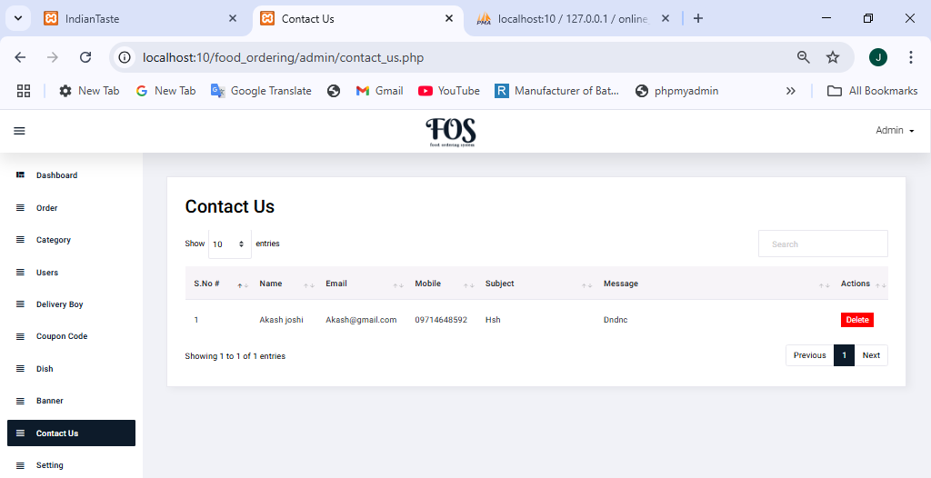

Setting page

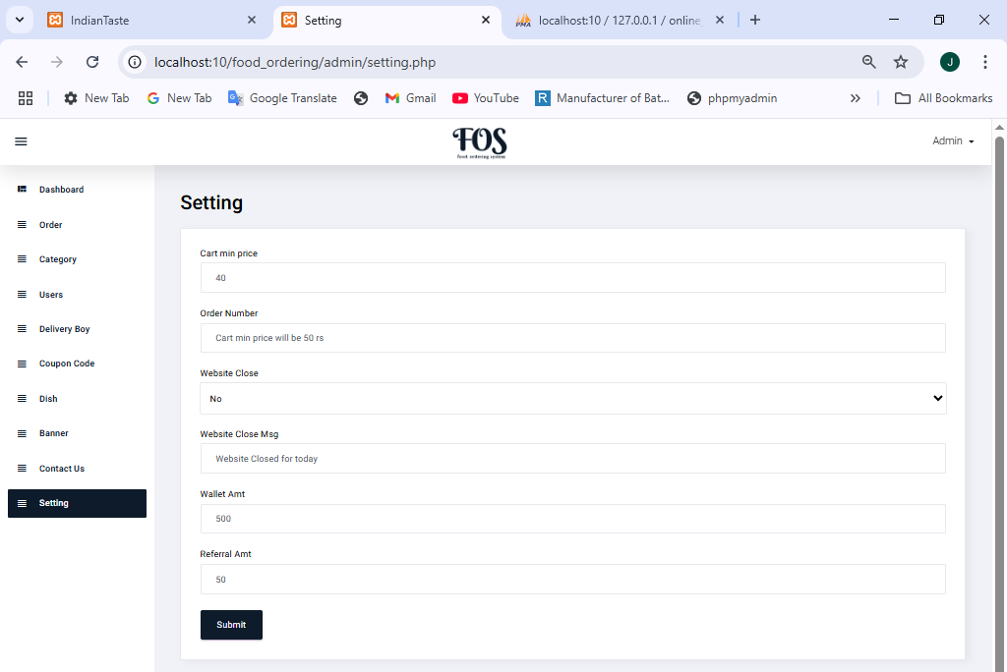

## 

## 12. BIBLIOGRAPHY

During the project, we referred to various resources that were provided to us for assistance apart fromreceiving help from our guide in the project titled "tribal culture website". The following list provides thebooks and resources that we referred.

## 

|  |  |  |
| --- | --- | --- |
| No. | Book Name | Description |
| 1. | PHP: The Complete  Reference | Author Name:- Steven Holzner Edition:- 1st |
| 2. | JavaScript and JSON Author Name:- Sai Srinivas Sriparasa Essentials | Publisher :- Packet Publishing Limited (26 October 2013) JavaScript and JSON Essentials |
| 3. | Bootstrap | Author Name:- Jake Spurlock Edition:- 1st  Publisher:- O'Reilly Media Bootstrap |

**Libraries**

* Bootstrap: Documentation. Retrieved from <https://getbootstrap.com/>
* jQuery: Documentation. Retrieved from https https://jquery.com/

## 13. WEB REFERENCES

* <https://www.w3schools.com/>
* <https://stackoverflow.com/questions>
* <https://boostrap.com/>
* <https://chatgpt.com/>
* <https://youtube.com/>